EVALUATION OF WATERMELON VARIETIES 2012, JAY, FLORIDA
Darcy E. P. Telenko, Libbie Johnson, and William Wendt

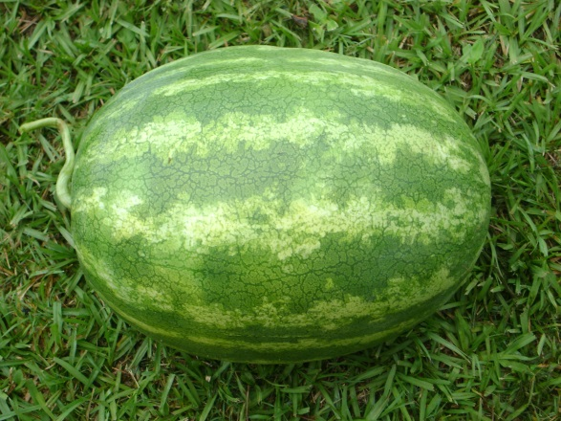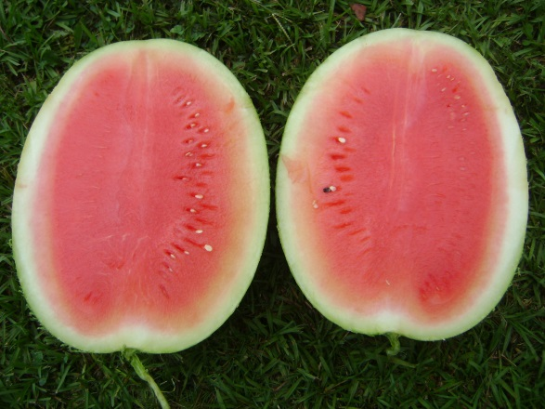

PURPOSE: To evaluate watermelon varieties for performance and yield.

EXPERIMENTAL DESIGN:

Twelve transplants planted in 24-ft row per plot with 7-ft row spacing

Four randomized complete blocks

VARIETY AND COMPANY:

- 7387 HQ Abbot and Cobb
- Tri-X 313 Syngenta
- Liberator Abbot and Cobb
- Distinction Syngenta
- 7167 Abbot and Cobb
- 7197 HQ Abbot and Cobb
- 5234 Plus Abbot and Cobb
- SUR 0241 Seminis
- Sweet Polly Siegers
- Diplomat Nunhems
- Banner Nunhems
- Fascination Syngenta
- WDL 9409 Syngenta
- Sugar Heart Zeraim Gedera
- 7187 HQ Abbot and Cobb
- Majestic Seminis
- Sugar Coat Zeraim Gedera
- 7177 HQ Abbot and Cobb
- Troubador Harris Moran
- RWT8231 Syngenta
- Revolution Nunhems
- Citation Sakata
- WDL 9408 Syngenta
- 7267 HQ Abbot and Cobb
- WDL 9405 Syngenta
- Crunchy Red F1 Harris Moran
- Declaration Nunhems
- Bold Ruler Sakata
- Liberty Nunhems
- Affirmed Sakata
- Wrigley Seminis
- Melody Syngenta
- Imagination Syngenta

  - ADDITIONAL INFORMATION:
    - Location: Jay Research farm
    - Crop history:
    - Land preparation: transplants planted in center of the bed with drip-irrigation
    - Planting date and cultivar: 13 Apr 2012
    - Soil type: Orangeburg sandy loam

Table 1. Effect of variety on harvestable melon, weight, and size.
Variety | % germination | # of melon/plot |  | Ave. fruit (lbs) | Ave. fruit length (in.) | Ave. fruit circumference (in.) | Hallow heart rating
 |  | 27 Jun | 18 Jul
7387 HQ | 97.66 | 8.3 | 3.8 | 19.6 | 14.8 | 30.4 abc | 0.0
Tri-X 313 | 96.09 | 17.8 | 2.3 | 21.0 | 13.9 | 32.8 a | 0.0
Liberator | 93.75 | 16.0 | 3.3 | 18.3 | 13.7 | 29.5 bc | 0.0
Distinction | 92.97 | 17.0 | 1.0 | 23.5 | 15.5 | 31.0 ab | 0.0
7167 | 92.19 | 10.5 | 2.0 | 19.2 | 14.2 | 29.5 bc | 0.0
7197 HQ | 89.84 | 14.8 | 2.5 | 19.3 | 15.2 | 29.8 bc | 0.0
5234 Plus | 89.06 | 8.5 | 2.5 | 22.3 | 13.8 | 29.8 bc | 0.0
SUR 0241 | 89.06 | 14.0 | 3.0 | 16.7 | 13.0 | 28.8 bc | 0.0
Diplomat | 86.72 | 10.5 | 6.5 | 76.7 | 16.4 | 30.7 abc | 0.7
Banner | 86.72 | 15.3 | 3.3 | 21.6 | 16.5 | 28.9 bc | 0.3
Fascination | 86.72 | 15.3 | 4.5 | 20.6 | 12.6 | 30.9 ab | 0.0
WDL 9409 | 85.94 | 18.8 | 4.8 | 19.3 | 14.8 | 28.9 bc | 0.0
Sugar Heart | 83.59 | 11.0 | 2.5 | 17.5 | 14.2 | 29.8 c | 0.0
7187 HQ | 82.03 | 19.0 | 2.5 | 20.8 | 15.6 | 32.2 ab | 0.5
Majestic | 81.25 | 13.8 | 2.3 | 19.7 | 14.2 | 31.1 ab | 0.0
Sugar Coat | 81.25 | 10.0 | 1.8 | 18.7 | 13.8 | 29.7 bc | 1.3
7177 HQ | 79.69 | 17.0 | 1.8 | 18.2 | 13.8 | 29.7 bc | 0.0
Revolution | 77.34 | 11.8 | 3.8 | 19.6 | 16.6 | 28.5 c | 0.5
 | - | NS | NS | NS | NS | 0.0471 | NS
Sweet Polly | 88.28 | 25.0 | 0.0 | 20.68 | 11.67 | 31.00 | 0.0
Troubador | 79.69 | 9.0 | 0.0 | 14.0 | 11.67 | 27.3 | 0.0
RWT8231 | 79.69 | 14 | 0.0 | 9.56 | 9.67 | 28.33 | 0.0
Citation | 60.16 | 18 | 0.0 | 15.88 | 12.00 | 32.00 | 0.0
WDL 9408 | 77.34 | 33 | 0.0 | 23.41 | 13.33 | 33.00 | 0.0
7267 HQ | 76.56 | 16 | 0.0 | 19.63 | 12.67 | 32.67 | 0.0
WDL 9405 | 71.88 | 10 | 0.0 | 16.46 | 14.00 | 33.00 | 0.0
Crunchy Red F1 | 70.31 | 5 | 0.0 | 13.80 | 11.33 | 31.67 | 0.0
Declaration | 70.31 | 14 | 0.0 | 18.49 | 12.67 | 33.00 | 0.0
Bold Ruler | 70.31 | 10 | 0.0 | 16.74 | 12.00 | 29.00 | 0.0
Liberty | 66.41 | 6 | 0.0 | 19.55 | 11.67 | 27.00 | 0.0
Affirmed | 64.06 | 7 | 0.0 | 20.33 | 15.67 | 33.00 | 0.0
Wrigley | 62.50 | 15 | 0.0 | 18.68 | 13.00 | 30.33 | 0.0
Melody | 58.59 | 8 | 0.0 | 15.29 | 11.33 | 29.67 | 0.0
Imagination | 39.84 | 12 | 0.0 | 15.37 | 11.33 | 32.67 | 0.0
^{w} Means are not significantly different according to Fisher’s Protected LSD (P=0.05). Varieties with gray fill planted in only one plot, data not replicated.

